Savitoj Baath 500694905 Jason Vu 500655822 Braeden Millette 500712513

Technical Report

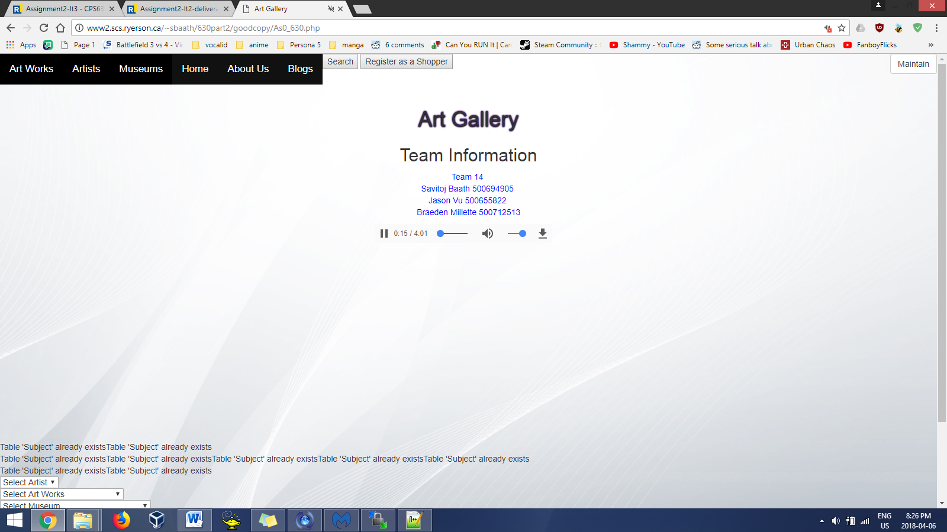

The main page of the website has a menu on the top of the screen with the Maintain button at the top right, and 3 mini drop down menus at the bottom of the page.

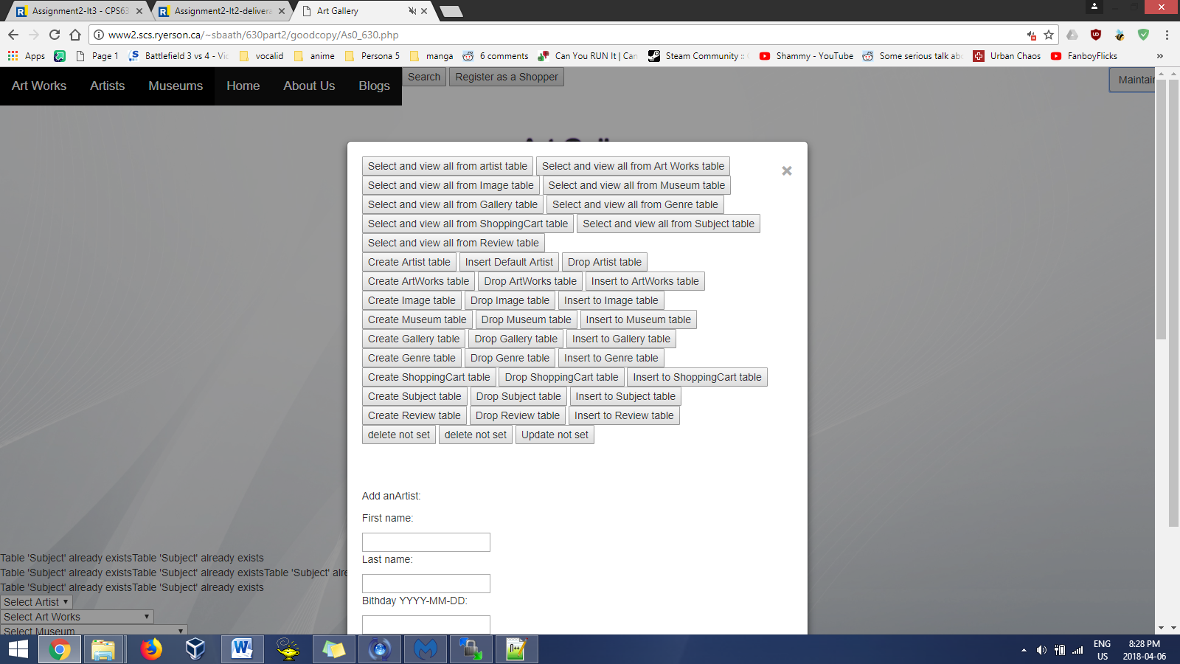When the maintain button is clicked, a box appears with the options that help maintain the database.

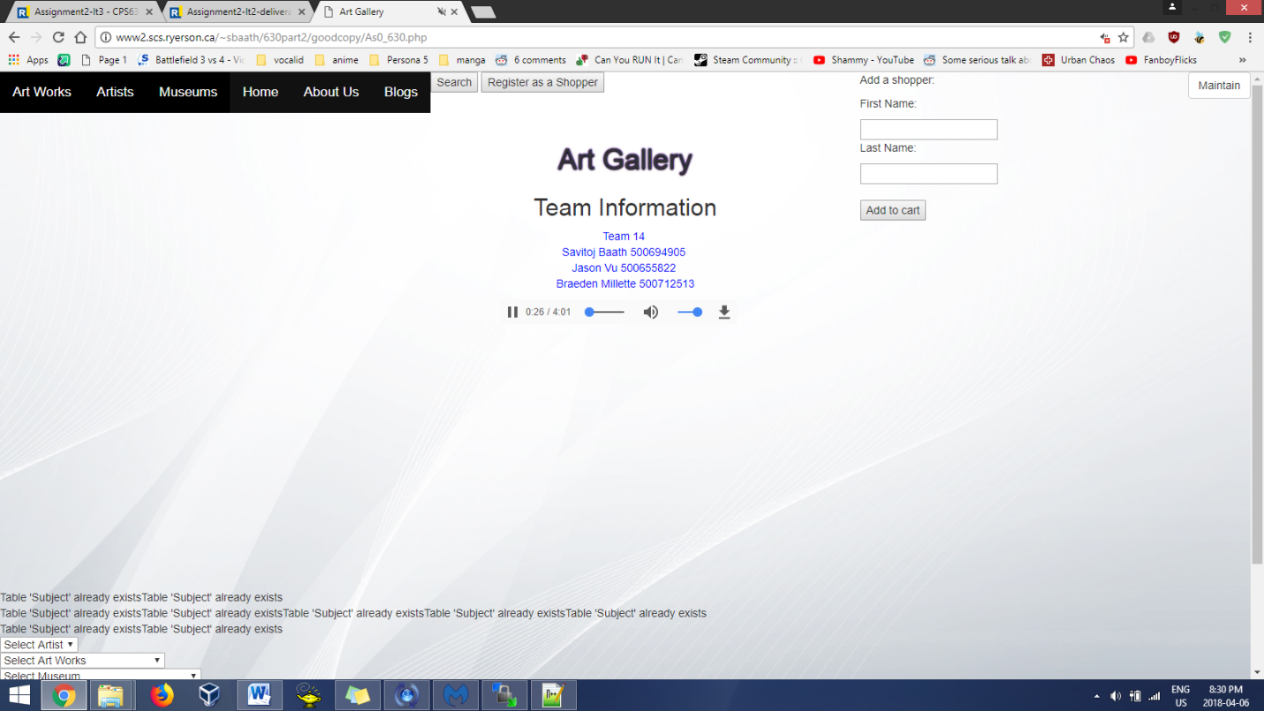Similarly, clicking the Register as a shopper button brings up a hidden textbox that allows the user to register in the shopping cart database.

Furthermore, when the search button is clicked, a hidden textbox appears that allows the user to search the database, and the results appear on the bottom of the page.

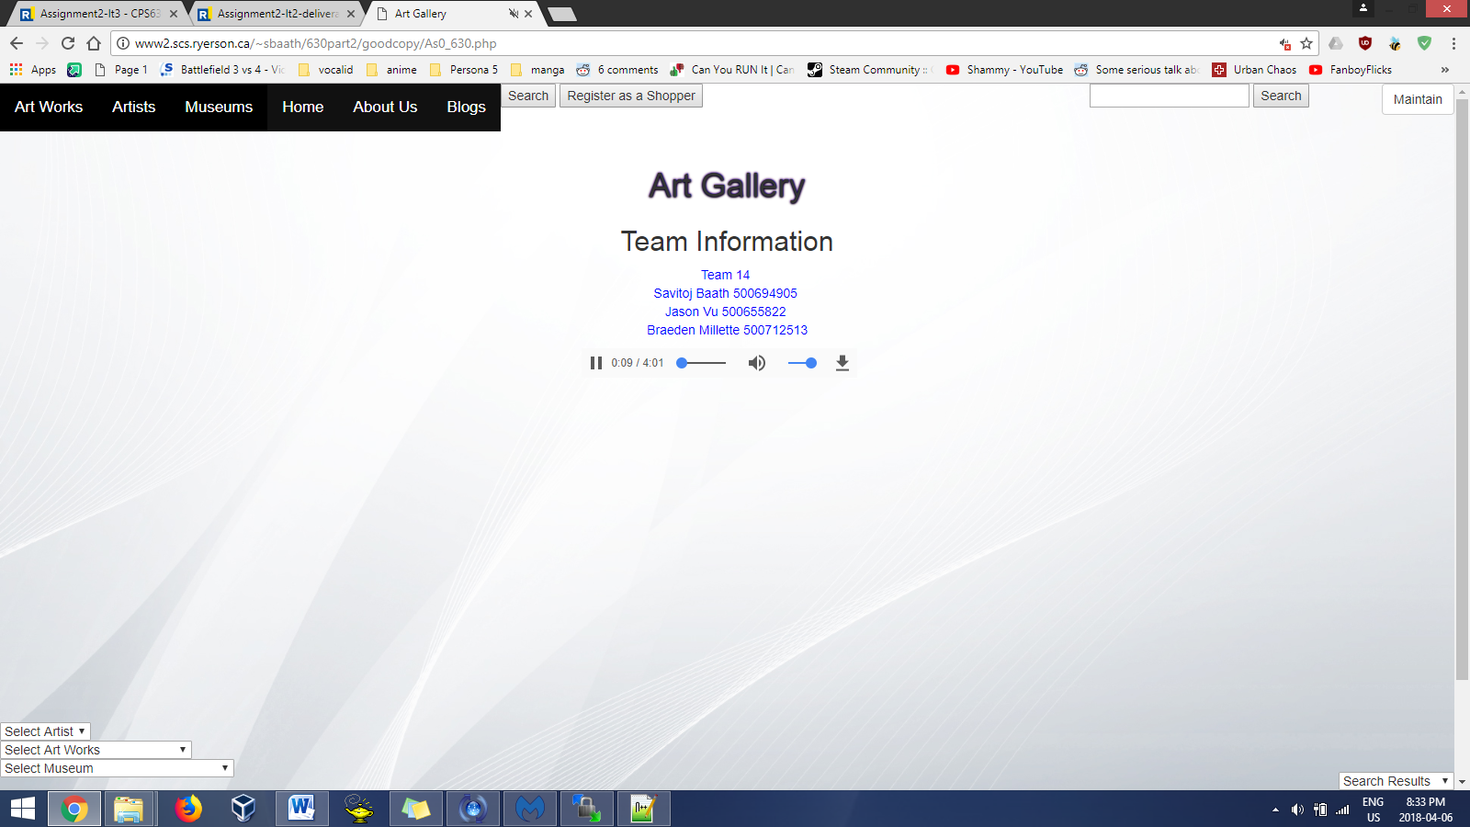

The names of the tables were assigned via the information given from the requirements. The names are as stated: Artists, ArtWorks, Museum, Image, Genre, Gallery, Review, Subject, and ShoppingCart. Each table had the proper fields assigned to it. For example the artist table would need date of birth, date of death, name, a picture of the artist, and a general description. The museum table would have different fields, and does not need a date of birth or date of death field. For the museum table, more suitable fields would be a picture of the museum, date it was created, general description, the name of the museum, and the address. Appropriate fields were assigned to each table. The tables also had primary keys assigned to them. A primary key for the museum table was the name of the museum, while for the artist table; the primary key was the name of the artist. A primary key for the art works table was the name of the painting. The rest of the tables were given primary keys as required. The tables are related to each other by their fields. The artist table had fields related to artist, while the art works table had fields related to the artworks. The museum table could retrieve the important information from artworks and artist to fill the table. The image table would retrieve the names and sizes of the images used by all the tables. To access the tables, the buttons were placed in the maintain mode.



The design and implementation of the maintain mode followed a process. The select, create, insert, and drop buttons are used to modify the tables in the databases. Each table has its own select, create, insert, and drop button. The select buttons were placed at the top of in maintain mode, followed by the drop, insert, and create buttons. Furthermore, the drop, insert, and create buttons are organized with create being first, followed by drop and insert. The SQL command INSERT INTO was used to implement the insert command. The SQL command CREATE TABLE was used to implement the create command. The SQL command DROP TABLE was used to implement the drop command. The SQL command SELECT \* FROM was used to implement the select command. To search through the database, a combination of PHP, HTML, and SQL was used. PHP variables and html forms were used to get the value from the textbox, and compare the values to see if they matched the ones in the database. The SQL command would select the value in the database, if there was a match.

At design, we identified the artist , art works, and museum class as the three main classes. The tables were derived around these classes as the information from them was used in every table. For example, the information in the artworks table was used in the museum, artist, image, genre, subject tables. The tables were derived as a flow chart connecting to the main class, and the tables would inherit and tweak the data from the main class. MCV pattern was applied to our application via the way the database was manipulated. The database would have tables stored server side, and update the values stored in the tables. The user would see the updated table values and would use them to do a task. The controller would then manipulate the data in the tables by deleting, inserting, or dropping them. The database would then update the tables based on which operation was performed, and the cycle repeats.